Other distributions
This reading explores some useful but less common distributions you may encounter in your work as a data analyst.

1. Geometric and Negative Binomial Distributions
The geometric and negative binomial distributions are closely related to the binomial distribution. Recall that:
The Bernoulli distribution is the simplest discrete probability distribution and models a single trial with two possible outcomes: success (with probability p) and failure (with probability 1 - p). It's like flipping a coin once, where you either get heads (success) or tails (failure).
The binomial distribution extends the Bernoulli distribution to multiple trials. It models the number of successes in a fixed number of independent Bernoulli trials. For example, if you flip a fair coin 10 times, the binomial distribution can tell you the probability of getting exactly 5 heads. The binomial distribution is parameterized by n (the number of trials) and p (the probability of success in each trial).

Geometric Distribution
The geometric distribution is related to the binomial distribution. Instead of counting the number of successes in a fixed number of trials, it counts the number of trials needed to achieve the first success.
Example: Suppose you are a quality control inspector at a factory, and you are inspecting light bulbs for defects. Each light bulb you inspect has a 10% chance of being defective (with p=0.1). You want to know the probability of finding the first defective light bulb on the k-th inspection. The geometric distribution models this scenario, providing the probability that the first success (finding a defective light bulb) occurs on the k-th trial. You can see it visualized in the plot below. Look at the heights of the bars. Do you notice that each next bar is smaller than the previous one? Think about why this would be the case (hint: the probability of finding a defective light bulb on each inspection is 0.1, regardless of what happened before).

Negative Binomial Distribution
The negative binomial distribution is a more general case of the geometric distribution. While the geometric distribution counts the number of trials needed to achieve the first success, the negative binomial distribution counts the number of trials needed to achieve a specified number of successes (r).
Example: Imagine you are a salesperson and your quota for the day is to make three sales (r=3). You are interested in how likely this is to happen after interacting with a certain number of customers. Each customer interaction has a 16.6 % chance of resulting in a sale (with p=1/6), and you are interested in the probability of achieving your third sale on the k-th interaction. The negative binomial distribution models this scenario, providing the probability that the third success (sale) occurs on the k-th trial. If this example is hard to understand, see exactly the same example below, but with dice:
Alternative example: Suppose you are rolling a six-sided die and you want to know the probability of rolling a 6 (success) for the third time on the k-th roll. Here, p=1/6 and r=3. The negative binomial distribution models this scenario, providing the probability that the third success occurs on the k-th trial.

In summary, while the binomial distribution focuses on the number of successes in a fixed number of trials, the geometric and negative binomial distributions focus on the number of trials needed to achieve one or more successes. These distributions are particularly useful for modeling the occurrence of events over time.

2. Poisson, Exponential and Gamma Distributions
These distributions extend concepts from the distributions you have seen above. While the distributions above count the number of successes given the number of trials, these distributions incorporate the element of time.
- The Poisson distribution is still a discrete distribution and models the number of events occurring within a fixed time interval, similar to how the binomial distribution counts the number of successes in a set number of trials.
- The exponential and gamma distributions are continuous distributions, as they measure the events with respect to (continuous) time. The exponential distribution measures the time between individual events, similar to how the geometric distribution counts the number of trials until the first success.
- Lastly, the gamma distribution generalizes the exponential distribution by modeling the total time until a specified number of events occur, paralleling the negative binomial distribution which counts the number of trials needed to achieve a specified number of successes.

Poisson Distribution
The Poisson distribution is a discrete distribution that models the number of events occurring within a fixed interval of time. It is parameterized by λ, which represents the average number of events in the interval. This distribution is particularly useful for modeling rare events over a continuous period.
The Poisson distribution is related to the binomial distribution but differs in that it models the number of events in a fixed interval rather than the number of successes in a fixed number of trials.

Example: Suppose you are analyzing the number of customer arrivals at a bank within an hour, with an average arrival rate of 3 customers per hour (λ = 3). The plot displays the Poisson distribution with an average rate of 3 events per interval, which corresponds to the example. The x-axis represents the number of events k, and the y-axis represents the probability of observing that number of events. The bars indicate the probability mass function (PMF), showing that the most likely number of events is around 3. It helps you understand what are the probabilities for any certain number of customers arriving at the bank within an hour. The distribution extends to infinity: any large number of customers can come within any hour, the probability just becomes increasingly small.

Exponential Distribution
The exponential distribution is a continuous probability distribution that models the time between events. It closely relates to the poisson distribution, as the events are of exactly the same type, but instead of fixing the time and counting the events, now you want to understand how much time would pass between the events. It is characterized by a rate parameter ( λ ), which represents the average number of events per unit time. One key property of the exponential distribution is its memorylessness, meaning the probability of an event occurring in the future is independent of when the last event occurred in the past.
The exponential distribution is the continuous counterpart to the geometric distribution. While the geometric distribution counts the number of trials until the first success, the exponential distribution measures the time until the first event occurs.

Example: Analyzing the customer arrivals at the bank from the previous example, you want to model the time between the arrivals of the customers (an average rate is still 3 per hour). The plot displays the exponential distribution with a rate of 3 events per unit time. The x-axis represents the time between events, and the y-axis represents the probability density. The curve indicates that shorter times between events are more likely, with the probability density decreasing exponentially as time increases.

Gamma Distribution
The gamma distribution extends the exponential distribution by modeling the total time until an event occurs a specified number of times. It is parameterized by a shape parameter k (representing the number of events) and a rate parameter λ (representing the rate of occurrence of the events). While the exponential distribution models the time between individual events, the gamma distribution models the cumulative time until multiple events occur.
The gamma distribution is the continuous counterpart to the negative binomial distribution. While the negative binomial distribution counts the number of trials needed to achieve a specified number of successes, the gamma distribution measures the total time until a specified number of events occur.
The exponential distribution equals the gamma distribution with the parameter k = 1, just like the geometric distribution equals the negative binomial distribution with k = 1.
Example: Suppose you are managing the same bank and you want to model the time until the 5th customer arrives, with customers still arriving at an average rate of 3 per hour (λ=3, k = 5).

Other examples: Here are some more examples for illustrating the Poisson, exponential, and gamma distributions: The number of emails received by a customer support team in an hour, the time between successive eruptions of a geyser, the total time required for a server to handle five consecutive requests, the number of cars passing through a toll booth in a minute, the time between consecutive arrivals of trains at a station (assuming they arrive randomly at a constant rate).

Deep Analysis: Probability Distributions for Data Analysts
I can see you've uploaded a reading on five distributions — Geometric, Negative Binomial, Poisson, Exponential, and Gamma. Let me go well beyond the textbook descriptions and give you practical implementations you can drop directly into Google Sheets or Proton Sheets, along with simulations and real-world scenarios.

Summary of the Five Distributions
Distribution Relationships
All five distributions form a tightly connected family. The geometric → negative binomial relationship mirrors the exponential → gamma relationship. The bridge between the discrete and continuous families is the Poisson process: events occurring at constant rate λ over time produce Poisson counts (discrete) and exponential/gamma waiting times (continuous).

Key Performance Indicators

Key Performance Indicators
Distributions covered
5
–2 discrete, 3 continuous
Key relationships
4 pairs
–Geometric→NegBin, Exp→Gamma, Geo↔Exp, NegBin↔Gamma
Spreadsheet formulas
15+
▲Native + custom
Simulation methods
2
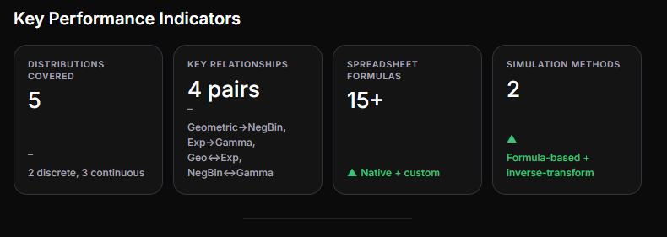

▲Formula-based + inverse-transform

1. Geometric Distribution

Deeper Analysis
The geometric distribution answers: "How many attempts until the first success?" Its PMF is:
P(X = k) = (1 − p)^(k−1) · p
for k = 1, 2, 3, … (counting the trial on which the first success occurs).
Key properties:
- Mean: 1/p — if p = 0.1, expect ~10 trials on average before the first success
- Variance: (1 − p) / p²
- Memorylessness: P(X > m + n | X > m) = P(X > n) — the distribution "resets" after every failure. This is the same property the exponential distribution exhibits in continuous time.
- The probability of needing more than k trials is P(X > k) = (1 − p)^k

Spreadsheet Implementation (Google Sheets & Proton Sheets)
Both applications use the same formula syntax. Here's a setup:
Cell | Content
B1 | 0.1 (your probability p)
A4:A33 | Numbers 1 through 30 (trial index k)
B4 | =(1-$B$1)^(A4-1)*$B$1 — drag down to B33
This gives you the PMF column. Add a cumulative column:
Cell | Formula
C4 | =(1-$B$1)^A4 — this is P(X > k), the survival function
D4 | =1-C4 — this is P(X ≤ k), the CDF

Practical Cases
Software QA Testing: A tester runs automated tests. Each test has a 5% chance of revealing a critical bug (p = 0.05). How many test runs until the first bug is caught? Expected: 20 runs. Probability of catching it within 10 runs: 1 − (0.95)^10 ≈ 40.1%.
Customer Acquisition: A startup cold-calls prospects with a 2% conversion rate. The geometric distribution tells you how many calls until your first sale. Change p and watch the distribution shift — a useful sensitivity analysis in a sheet.
Job Interview Rejections: You send applications with a 15% interview-invite rate. The geometric model shows why "keep trying" is statistically sound: the probability of never getting an interview in 20 applications is only (0.85)^20 ≈ 3.9%.

2. Negative Binomial Distribution

Deeper Analysis
The negative binomial generalizes the geometric: "How many trials until the r-th success?" Its PMF is:
P(X = k) = C(k−1, r−1) · p^r · (1−p)^(k−r)
where C(k−1, r−1) is the binomial coefficient choosing which of the first k−1 trials were the other r−1 successes.
Key properties:
- Mean: r / p
- Variance: r(1 − p) / p²
- When r = 1, this reduces to the geometric distribution

Spreadsheet Implementation
Cell | Content
B1 | 0.166 (p = 1/6, from the dice example)
B2 | 3 (target number of successes r)
A4:A60 | Trial indices k = 3, 4, 5, ..., 59
B4 | =COMBIN(A4-1, $B$2-1) * $B$1^$B$2 * (1-$B$1)^(A4-$B$2)
C4 | =SUMPRODUCT($B$4:B4) — cumulative probability up to row
Note: COMBIN() is available natively in both Google Sheets and Proton Sheets.

Practical Cases
Sales Pipeline Modeling: Your close rate is 25% (p = 0.25) and you need 5 closed deals (r = 5) to hit quota. The negative binomial tells you the expected number of prospect meetings needed: r/p = 20. But it also shows the spread — there's meaningful probability you'll need 25+ meetings. This is far more informative than just the mean for capacity planning.
Clinical Trials: In a Phase II oncology trial, you need to observe 3 responders among patients treated sequentially. If the response rate is 12% (p = 0.12), the distribution tells you the expected enrollment (25 patients) and the probability of needing more than 40 patients before reaching 3 responders — useful for budgeting site costs.
Manufacturing Quality: An assembly line produces parts with a 98% pass rate. You need 50 good parts (r = 50). How many blanks should you start? Mean = 51.02, but the 95th percentile is around 57 — order 57 to be safe.

3. Poisson Distribution

Deeper Analysis
The Poisson distribution models the count of events in a fixed interval when events occur independently at a constant average rate λ. Its PMF is:
P(X = k) = e^(−λ) · λ^k / k!
Key properties:
- Mean = Variance = λ (this equality is a diagnostic: if your observed variance >> mean, you're dealing with overdispersion and the Poisson may not fit)
- As λ grows, the Poisson approaches a Normal distribution (practically, when λ > ~20)
- The sum of independent Poisson(λ₁) and Poisson(λ₂) is Poisson(λ₁ + λ₂) — additive property

Spreadsheet Implementation
Both Google Sheets and Proton Sheets support this natively:
Cell | Content
B1 | 3 (λ, average events per interval)
A4:A24 | k = 0, 1, 2, ..., 20
B4 | =POISSON.DIST(A4, $B$1, FALSE) — PMF
C4 | =POISSON.DIST(A4, $B$1, TRUE) — CDF
If POISSON.DIST is unavailable, use the manual formula:
Cell | Formula
B4 | =EXP(-$B$1) * $B$1^A4 / FACT(A4)

Practical Cases
Website Traffic Spikes: Your e-commerce site averages 2.5 server errors per hour during peak load (λ = 2.5). What's the probability of zero errors in an hour? P(X=0) = e^(−2.5) ≈ 8.2%. Probability of 5+ errors? 1 − CDF(4) ≈ 10.8%. This directly informs alerting thresholds.
Call Center Staffing: A support line receives 8 calls/hour on average (λ = 8). To meet a service level of answering 90% of calls immediately, you need enough agents so that P(arrivals > agents) ≤ 10%. Using the CDF, you'd need at least 12 agents (P(X > 12) ≈ 8.9%).
Insurance Claim Frequency: A regional insurer processes an average of 15 property claims per week during storm season (λ = 15). The Poisson model helps reserve adequate adjustor capacity and estimate tail risk: P(X > 25) ≈ 0.9%, but when it happens, it's catastrophic.

4. Exponential Distribution

Deeper Analysis
The exponential distribution models the time between consecutive events in a Poisson process. Its PDF is:
f(x) = λ · e^(−λx) for x ≥ 0
Key properties:
- Mean: 1/λ
- Variance: 1/λ²
- Memorylessness: P(X > s + t | X > s) = P(X > t) — the only continuous distribution with this property alongside the geometric in discrete space
- Median: ln(2)/λ ≈ 0.693/λ — note the median is less than the mean, so the distribution is right-skewed

Spreadsheet Implementation
Cell | Content
B1 | 3 (rate λ, events per unit time)
A4:A53 | Time values x = 0, 0.1, 0.2, ..., 5.0
B4 | =$B$1 * EXP(-$B$1 * A4) — PDF (density)
C4 | =1 - EXP(-$B$1 * A4) — CDF (probability time ≤ x)

Practical Cases
Server Uptime / MTBF: A server cluster component fails at a rate of 0.02 failures/day (λ = 0.02, mean time between failures = 50 days). What's the probability the component lasts at least 60 days? P(X > 60) = e^(−0.02×60) = e^(−1.2) ≈ 30.1%. This feeds directly into redundancy planning.
Customer Service Wait Times: If customers arrive at a rate of 12/hour and service is exponentially distributed with the same rate, the median wait is ln(2)/12 ≈ 3.5 minutes. The long tail means some waits will be much longer — important for setting customer expectations.
Equipment Replacement Cycles: LED streetlights have a failure rate λ = 0.001/day. The expected lifetime is 1000 days (~2.7 years), but because of memorylessness, a light that's already been running for 3 years has the same expected remaining life as a brand-new one. This challenges naive replacement schedules.

5. Gamma Distribution

Deeper Analysis
The gamma distribution models the total waiting time until k events occur in a Poisson process. Its parameters are shape k and rate λ (or alternatively shape α = k and scale θ = 1/λ).
When k is an integer, the gamma CDF reduces to:
P(T ≤ t) = 1 − e^(−λt) · Σ(i=0 to k−1) (λt)^i / i!
Key properties:
- Mean: k/λ
- Variance: k/λ²
- When k = 1, this becomes the exponential distribution
- The sum of k independent Exponential(λ) random variables is Gamma(k, λ) — this is the connection to the negative binomial

Spreadsheet Implementation (integer shape k)
For the CDF when k is a positive integer, use the relationship with the Poisson:
Cell | Content
B1 | 3 (rate λ)
B2 | 5 (shape k — number of events)
A4:A53 | Time values t = 0, 0.1, ..., 5.0
B4 | =1 - POISSON.DIST($B$2-1, $B$1*A4, TRUE) — CDF using Poisson relationship
Or manually if POISSON.DIST is missing:
Cell | Formula (for k=5, λ=3)
Helper C4:C8 | i = 0, 1, 2, 3, 4 (i.e., 0 to k−1)
B4 | =1 - EXP(-$B$1*A4) * SUMPRODUCT(ARRAYFORMULA(($B$1*A4)^{0;$B$2-1}/FACT({0;$B$2-1}))) — approximate, simpler to use POISSON.DIST
The cleanest approach for both Google Sheets and Proton Sheets:
Cell | Formula
B4 | =1 - POISSON.DIST($B$2 - 1, $B$1 * A4, TRUE)
This exploits the identity: Gamma CDF at t = 1 − Poisson CDF(k−1, λt).

Practical Cases
Project Completion Time: A software release requires 5 sequential QA stages, each taking an exponentially distributed time with mean 3 hours (λ = 1/3 per stage, or equivalently the total is Gamma(5, 1/3)). Expected total time: 15 hours. Probability of finishing within 10 hours: CDF(10) ≈ 7.3%. Within 20 hours: ≈ 87%. This gives realistic confidence intervals rather than point estimates.
Bank Customer Arrival (from the document): Time until the 5th customer arrives with λ = 3/hour. Mean = 5/3 ≈ 1.67 hours. The distribution shape changes dramatically with k: at k = 1 it's exponential (highly skewed), at k = 20 it's nearly bell-shaped.
Maintenance Budgeting: A fleet of delivery vans each experiences tire failures at rate λ = 0.004/day. You budget for the 4th tire failure (k = 4). Expected time: 4/0.004 = 1000 days. The gamma distribution shows the spread around this mean — useful for deciding when to proactively replace tires before failures cascade.

Simulation Tab — Drop-In Spreadsheet Design
Here's a complete layout you can build in Google Sheets or Proton Sheets to simulate all five distributions side by side:

Sheet 1: "Control Panel"
Cell | Label | Value
B1 | p (success prob) | 0.1
B2 | r (target successes) | 3
B3 | λ (rate) | 3
B4 | k (gamma shape) | 5
B5 | Simulations | 1000

Sheet 2: "Geometric Sim"
Use the inverse transform method: generate a uniform random number U, then compute X = CEILING(ln(U) / ln(1−p)).
Cell | Formula
A2 | =CEILING(LN(RAND()) / LN(1-'Control Panel'!$B$1), 1)
A3:A1001 | Drag down (1000 simulations)
C2:C30 | Bin labels 1–30
D2 | =COUNTIF($A$2:$A$1001, C2) — frequency per bin
E2 | =D2/$B$5 from Control Panel — empirical probability
F2 | =(1-'Control Panel'!$B$1)^(C2-1)*'Control Panel'!$B$1 — theoretical PMF
Plot E2:E30 (empirical) vs F2:F30 (theoretical) as overlapping bar/line combo.

Sheet 3: "Negative Binomial Sim"
For r successes with probability p, simulate r geometric random variables and sum them:
Cell | Formula
B2 | =SUM(ARRAYFORMULA(CEILING(LN(RANDARRAY('Control Panel'!$B$2,1))/LN(1-'Control Panel'!$B$1),1)))
Repeat in B3:B1001 for 1000 simulations. RANDARRAY generates r random uniforms; CEILING(...) converts each to a geometric sample; SUM gives total trials to reach r successes.
Bin and compare with the theoretical formula using COMBIN.

Sheet 4: "Poisson Sim"
Use the Knuth algorithm approximation via recursion, or the simpler approach — leverage that Poisson(λ) is the limit of Binomial(n, λ/n) for large n:
Cell | Formula
A2 | =BINOM.INV(1000, 'Control Panel'!$B$3/1000, RAND())
This approximates Poisson(λ) by Binomial(1000, λ/1000). With n = 1000 and λ = 3, the approximation is excellent. Repeat 1000 times, then histogram with COUNTIF.
Alternatively, for exact simulation, implement the Knuth algorithm:
- Generate U₁, U₂, … uniforms
- Find smallest k where Π(Uᵢ) < e^(−λ)
- That k is your Poisson sample
This is harder in pure spreadsheet formulas but doable with a helper column using PRODUCT and EXP.

Sheet 5: "Exponential Sim"
Inverse transform: X = −ln(U) / λ
Cell | Formula
A2 | =-LN(RAND()) / 'Control Panel'!$B$3
A3:A1001 | Drag down
Bin into 0.1-width intervals, histogram with COUNTIFS, overlay the theoretical PDF =λ*EXP(-λ*x).

Sheet 6: "Gamma Sim"
Sum k exponential samples:
Cell | Formula
A2 | =-SUM(LN(RANDARRAY('Control Panel'!$B$4, 1))) / 'Control Panel'!$B$3
RANDARRAY(k,1) generates k uniforms, LN transforms each to exponential, SUM adds them to get Gamma(k, λ). Repeat 1000 times.

Empirical vs Theoretical Comparison
Once you've built the simulation tabs, here's the key analytical payoff — compare simulated frequencies against theoretical probabilities:
012345678910Number of events (k)0.000.050.100.150.20ProbabilityundefinedsourcePoisson Simulation vs Theoryλ=3, 1000 simulations — empirical bars converge to theoretical PMF
And here's how the gamma distribution shape changes as k increases — demonstrating convergence toward normality:
0.00.51.01.52.02.53.03.54.04.55.05.56.06.57.0Time (t)0.00.20.40.60.81.0CDF (probability time ≤ t)k1k10k3k5Shape (k)Gamma CDF for Different Shape Valuesλ=3, k=1 is exponential, k=20 approaches normal shape
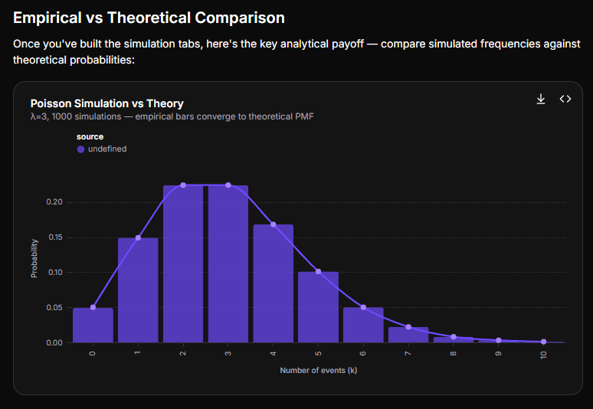

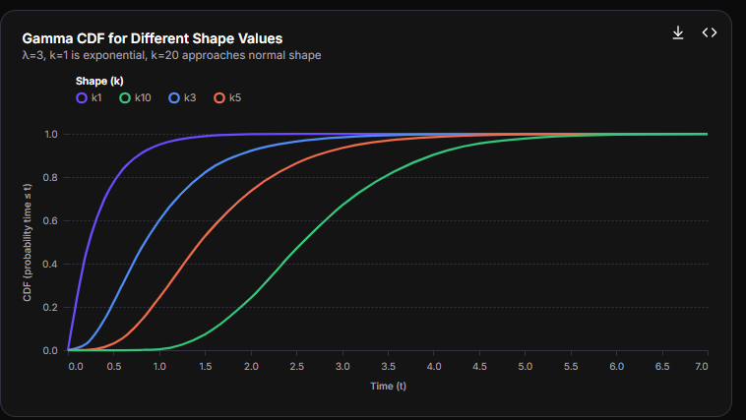

Findings & Key Insights
Memorylessness connects discrete and continuousinfo
The geometric and exponential distributions share the unique memoryless property — the only two distributions (one discrete, one continuous) with this characteristic. This makes them natural models for 'renewal' processes: after each event, the clock resets. Practically, this means a 5-year-old lightbulb has the same failure probability in the next hour as a brand-new one (if failures are truly exponential).
Poisson variance-mean equality is a diagnostic toolinfo
If you collect count data and find that variance >> mean, the Poisson assumption is violated (overdispersion). This commonly arises from clustered events, time-varying rates, or hidden dependencies. The negative binomial distribution often fits such data better because it has an extra parameter allowing variance > mean.
Inverse transform sampling works in pure spreadsheet formulasinfo
Every distribution covered here can be simulated in Google Sheets or Proton Sheets using only RAND(), LN(), and basic arithmetic — no add-ons or scripts required. The inverse transform method (generate U ~ Uniform(0,1), then apply F⁻¹(U)) is universally applicable. For discrete distributions like Poisson, use the recursive relationship P(k+1) = P(k) · λ/(k+1) or the Knuth algorithm.

Quick Reference: Which Distribution When?
Question you're asking | Discrete answer | Continuous answer
"Trials until 1st success?" | Geometric(p) | Exponential(λ)
"Trials/time until r-th success?" | Negative Binomial(r, p) | Gamma(k=r, λ)
"How many events in a fixed window?" | Poisson(λ) | N/A (use Poisson)
"Is variance ≈ mean?" | Yes → Poisson fits | If no → try Negative Binomial

Proton Sheets Note
Since you mentioned Proton Sheets — all the formulas above (EXP, LN, POISSON.DIST, COMBIN, FACT, RANDARRAY, COUNTIF, ARRAYFORMULA) use standard spreadsheet syntax that works identically in both Google Sheets and Proton Sheets. The simulation approach using RAND() and inverse transforms is fully portable. You can access Proton Sheets for end-to-end encrypted collaborative work at sheets.proton.me.
Would you like me to expand any section further, create additional visualization specs, or walk through a specific worked example end-to-end?

Based on my research, here's what really differentiates Proton Sheets from its competitors:

🔒 End-to-End Encryption Is The Core Differentiator
The single most important distinction is that Proton Sheets uses zero-access end-to-end encryption by default. This means:
Feature | Proton Sheets | Google Sheets | Microsoft Excel Online
Encryption at rest | ✅ Yes | ❌ No | ❌ No
Zero-knowledge architecture | ✅ Yes | ❌ No | ❌ No
Real-time collaboration | ✅ Yes | ✅ Yes | ✅ Yes
Data mining for ads | ❌ Never | ✅ Yes | ❌ Limited
Password-protected sharing | ✅ Yes | ⚠️ Paid plans only | ⚠️ Limited
The comparison image I generated above visualizes these core differences — note how Proton Sheets is the only one checking both encryption boxes while still supporting real-time collaboration.

🛡️ What This Means in Practice

Your Data Is Truly Private
- Every cell, formula, and attachment is encrypted before it leaves your device
- Even Proton staff cannot access your data — only you hold the encryption keys
- Your spreadsheets remain encrypted during transmission and storage

Protected From Multiple Threat Vectors
- Breaches: If Proton's servers are compromised, attackers get unreadable ciphertext
- AI Training: Unlike Google Workspace and Microsoft 365, your data is never used to train AI models
- Surveillance: Based in Switzerland, protected by some of the world's strongest privacy laws, outside US jurisdiction

Secure Collaboration Without Compromise
- Share with internal teams or external partners via password-protected links with expiration dates
- Grant granular permissions: view, comment, or edit rights
- External collaborators don't need a Proton account
- Revoke access at any time

🏢 Enterprise & Compliance Advantages

Built for Regulated Industries
- ISO 27001 certified and SOC 2 Type II audited
- Compliant with HIPAA, GDPR, CCPA, and other regulations
- Audit-ready sharing logs for compliance reporting
- Suitable for healthcare, finance, law firms, and government organizations

Administrative Control
- Central admin panel to oversee permissions, storage, and access
- Group-based access controls simplify governance
- Role-based permissions scale from 10 to 100,000+ users

🌍 Data Sovereignty & Jurisdiction
- Swiss-based hosting means protection under European privacy frameworks
- Your data cannot be compelled by US laws like the CLOUD Act
- Stays outside of US, EU, and UK surveillance jurisdictions

🧩 Ecosystem Integration
Proton Sheets isn't standalone — it's part of Proton Workspace, which bundles:
- Proton Mail — encrypted email
- Proton Calendar — private scheduling
- Proton Drive — secure cloud storage
- Proton Docs — encrypted word processing
- Proton Meet — private video conferencing
- Proton Pass — team password management
- Proton VPN — network security
- Lumo AI — privacy-first AI assistant
This creates a cohesive, encrypted productivity environment without vendor lock-in to Big Tech ecosystems.

⚖️ Tradeoffs to Consider
Advantage | Potential Limitation
End-to-end encryption | Some advanced AI features (like Copilot/Gemini) require server-side data access — not available
Open-source transparency | Smaller feature set compared to Google/Microsoft
Swiss privacy laws | May not suit all geographic compliance requirements
No vendor lock-in | Fewer third-party integrations

💰 Pricing Context
- Workspace Standard ($12.99–14.99/user/month): Includes 1 TB storage, Sheets, Docs, Mail, VPN, Pass, Meet
- Workspace Premium ($19.99–24.99/user/month): Adds Lumo AI, 3 TB storage, data retention policies
- Enterprise: Customizable for large organizations
Compared to buying services separately (Google Workspace + VPN + password manager), Proton Workspace offers bundled value with superior privacy by default.

🎯 Bottom Line
If data privacy, regulatory compliance, and sovereignty are priorities, Proton Sheets is fundamentally different because it protects you from threats that mainstream alternatives don't guard against — including provider-level data access, surveillance compulsion, and AI training. If maximum feature richness and third-party integrations matter more than encryption, Google Sheets or Microsoft Excel may still be preferable for certain use cases.
Would you like me to explore a specific comparison aspect further, such as migration paths from Google Workspace, or dive deeper into the compliance certifications?

